Cafeteria Management System — Database Project Report
Oracle 19c database design + PL/SQL + Flask front-end (SQL-only). Generated: 2026-05-08 23:23

1. System Overview
This system models a university cafeteria serving Students, Staff, and Guests. It supports menu management, order placement, order line items, inventory consumption via ingredient usage, employee handling of orders, shifts, payments/billing, and customer feedback.

2. ERD (Entity–Relationship Diagram)
The ERD shows the full relational schema using crow’s-foot notation, highlighting primary keys (PK), foreign keys (FK), and unique attributes (UQ). It also includes a logical (non-FK) link between DISCOUNT and CUSTOMER based on CUSTOMER_TYPE.
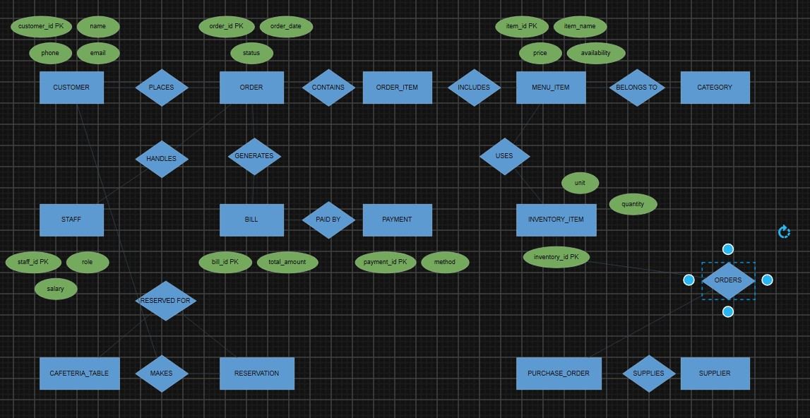
Figure 1 — ERD (Crow’s Foot) for Cafeteria Management System

3. EERD (Enhanced ER Diagram)
The EERD extends the ERD by adding enhanced modeling constructs:
- Specialization/Generalization: CUSTOMER → {Student, Staff, Guest} (disjoint, total)
- Specialization/Generalization: EMPLOYEE → {Cashier, Chef, Manager} (disjoint, total)
- Weak Entity: SHIFT depends on EMPLOYEE (identifying relationship)
- Derived attribute: MENU_ITEM.AVERAGE_RATING (computed from FEEDBACK)
- Composite attribute: CUSTOMER.CONTACT_INFO = {EMAIL, PHONE}
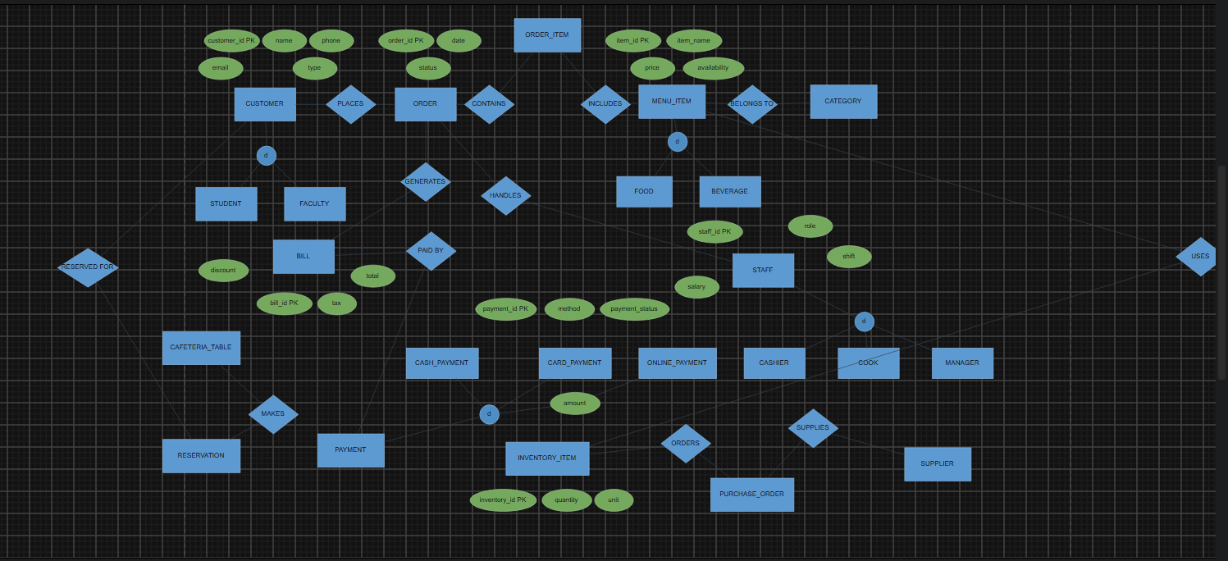
Figure 2 — EERD (Enhanced) for Cafeteria Management System

4. Key Entities & Business Rules (Summary)
- CUSTOMER places many ORDERS; each ORDER belongs to exactly one CUSTOMER.
- EMPLOYEE may handle many ORDERS; ORDER.EMPLOYEE_ID can be NULL (unassigned order).
- ORDER contains multiple ORDER_ITEM rows; each ORDER_ITEM references exactly one MENU_ITEM.
- PAYMENT is logically one-per-order (enforced by UNIQUE on PAYMENT.ORDER_ID).
- FEEDBACK is one-per-order at most (enforced by UNIQUE on FEEDBACK.ORDER_ID).
- INGREDIENT_USAGE defines bill-of-materials per MENU_ITEM; stock is deducted when ORDER_ITEM is inserted.
- SHIFT records work time per employee per date (unique per employee/day).
- DISCOUNT applies by CUSTOMER_TYPE and validity dates (logical rule, not a direct FK).

5. Normalization (3NF / BCNF)
The schema is normalized to reduce redundancy and update anomalies. Below is the normalization reasoning aligned with the implemented tables.

5.1 First Normal Form (1NF)
- All attributes are atomic (no repeating groups inside a single row).
- Order line items are separated into ORDER_ITEM instead of repeating columns in ORDER.
- Ingredient usage is separated into INGREDIENT_USAGE rather than embedding ingredients inside MENU_ITEM.

5.2 Second Normal Form (2NF)
Tables with non-key attributes depend on the whole primary key. ORDER_ITEM uses a surrogate key (ORDER_ITEM_ID) but still ensures QUANTITY, UNIT_PRICE, SUBTOTAL depend on the specific line item. INGREDIENT_USAGE enforces uniqueness on (ITEM_ID, INVENTORY_ID) so QUANTITY_REQUIRED depends on that pair.

5.3 Third Normal Form (3NF)
- CUSTOMER stores customer identity + type; discount rates are not stored in CUSTOMER to avoid transitive dependency; DISCOUNT holds discount rules.
- MENU_CATEGORY is separated from MENU_ITEM so category descriptions are not duplicated per item.
- PAYMENT is separated from ORDER so payment attributes (status/date/amount) do not create null-heavy columns in ORDER.
- FEEDBACK is separated from ORDER to avoid nullable feedback columns for orders without feedback.

5.4 BCNF Notes
Most tables satisfy BCNF because every determinant is a candidate key. Important constraints supporting BCNF:
- PAYMENT: UNIQUE(ORDER_ID) ensures one payment per order.
- FEEDBACK: UNIQUE(ORDER_ID) ensures at most one feedback per order.
- INGREDIENT_USAGE: UNIQUE(ITEM_ID, INVENTORY_ID) ensures a single quantity rule per ingredient per menu item.
- SHIFT: UNIQUE(EMPLOYEE_ID, SHIFT_DATE) ensures one shift record per employee per day.

6. Implementation Notes
- Oracle reserved keyword ORDER is implemented as quoted table name "ORDER".
- Sequences generate primary keys (Oracle 19c requirement).
- Triggers enforce business rules: auto OrderID, stock deduction, menu average rating maintenance, and delete protection for completed orders.
- Flask front-end uses python-oracledb connection pooling and calls SQL/PLSQL directly (no ORM).

— End of Report —

